Days 47-49: Autopsy Case Setup & Initial Triage
// 47-49 OVERVIEW & SCOPE
This block moves the Days 46-47 acquisition into a structured forensic case workflow using Autopsy. The E01 image is loaded as a data source, all ingest modules are run to completion, and a systematic triage is performed across the file tree, timeline, deleted files, thumbnails, and web artefacts. The objective at this stage is breadth of coverage and identification of areas warranting deeper investigation, not exhaustive analysis of every artefact.

// 01 CASE SETUP & DATA SOURCE INGESTION
$ Case Creation
Autopsy case created with the following parameters:

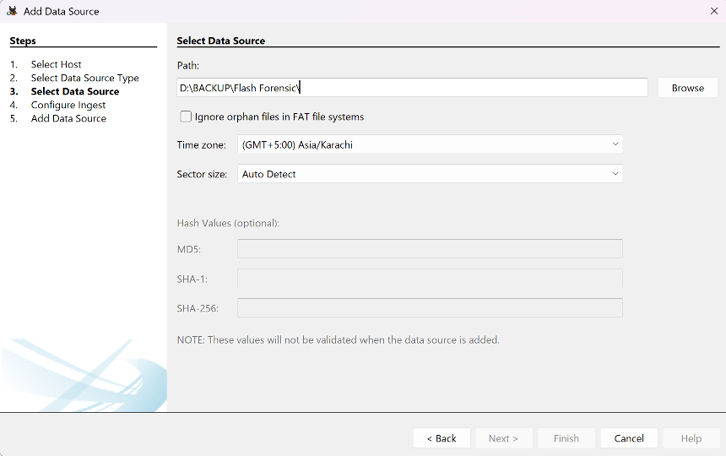
Figure 1 — Autopsy case creation.

// 02 INGEST MODULE CONFIGURATION & EXECUTION
All available ingest modules were enabled: Hash Lookup, Keyword Search, File Type Identification, EXIF Parser, Extension Mismatch Detector, Recent Activity, and Web Artefacts extraction. Each module's function was reviewed prior to enabling it.
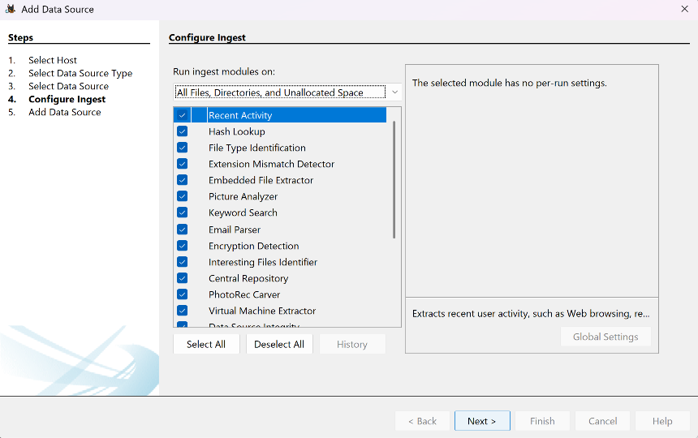
Figure 3 — Ingest module selection.

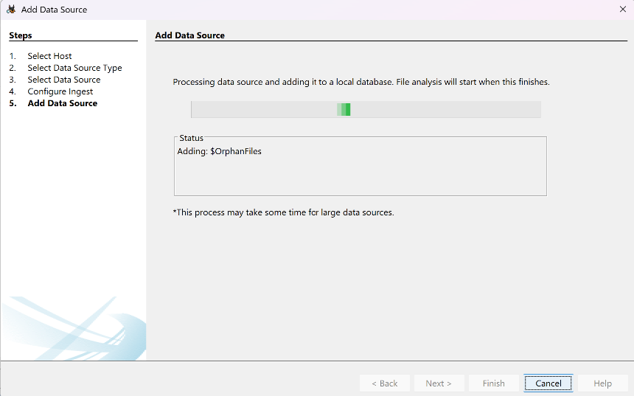
Figure 4 — Ingest execution.

// 03 FILE TREE OBSERVATIONS
The directory structure was reviewed across the user profile, Desktop, Documents, Downloads, AppData, and Temp directories, looking for extension mismatches, files in unexpected locations, and timestamps inconsistent with apparent purpose.
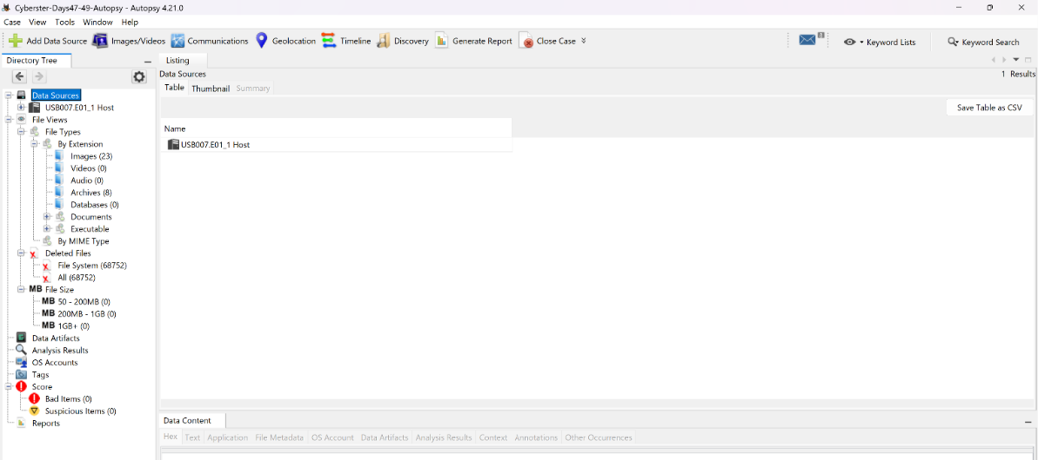
Figure 5 — File tree anomaly.
// 04 TIMELINE FINDINGS
The Timeline view was set to bracket the period preceding acquisition. Activity clusters — periods of concentrated file creation or modification — were prioritised over isolated single events.
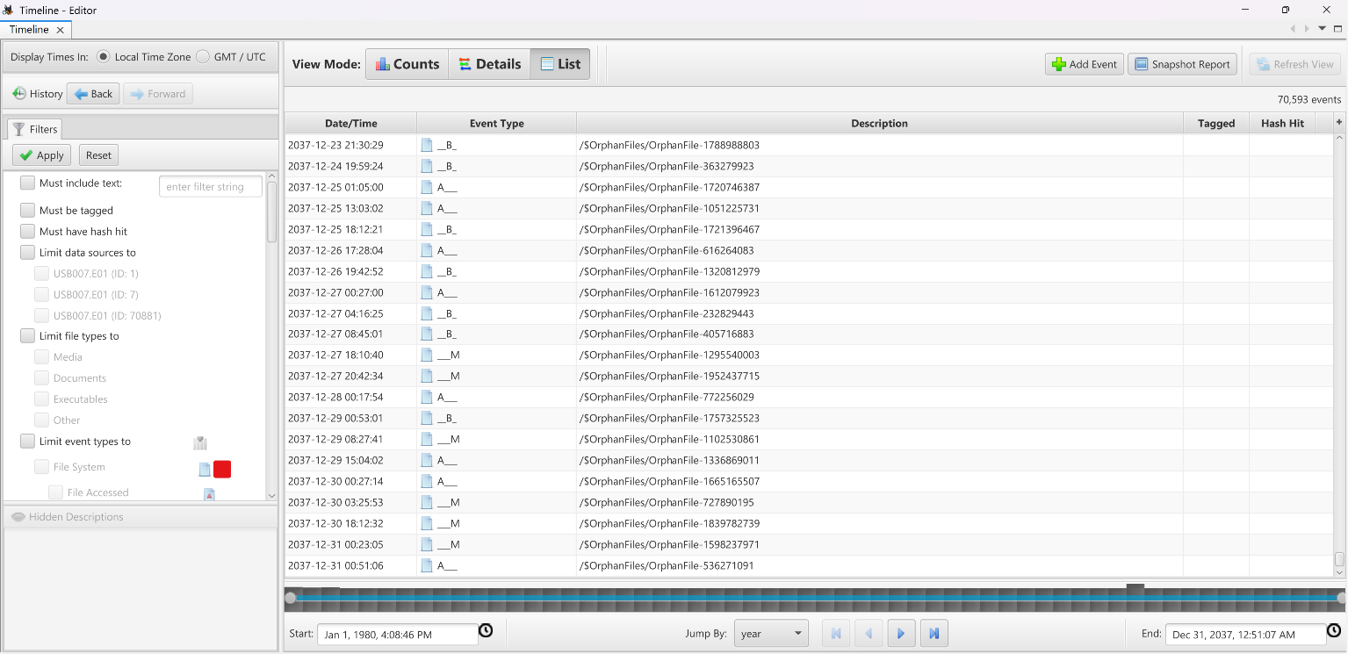
Figure 6 — Timeline activity cluster.
// 05 DELETED FILES RECOVERED
Autopsy's file carver was reviewed under File Views > Deleted Files. For each recovered item, file type, approximate disk location, and recovery completeness (full content vs. header-only) were recorded.
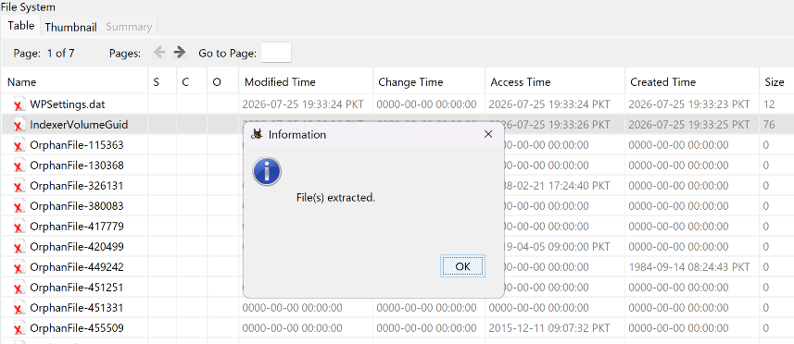
Figure 7 — Recovered/carved files
// 08 EXPORT & REPORTING
Autopsy's built-in HTML report was generated covering all flagged items, keyword hits, and carved files. Recovered files were exported into a case-referenced evidence folder structure and logged above.
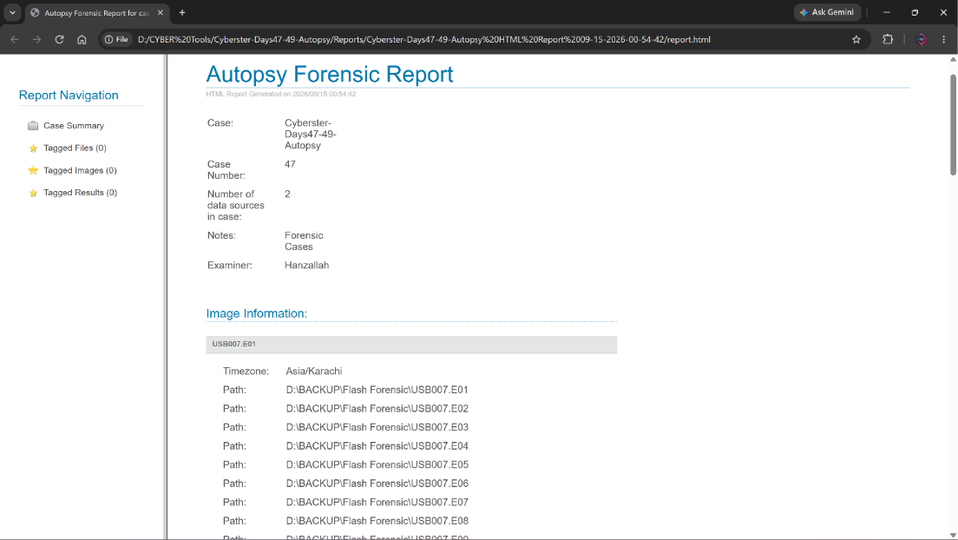
Figure 8— Case report export.

